Ryley Wells, 20068388

# Lab 4&5 Part 3

Overall, I believe my experiments and conclusions somewhat support the claim that the brute force approach to solving the subset sum problem runs in O(2n) efficiency, and that the Horowitz/Sahni implementation runs in O(n*2n/2). While the data does not demonstrate this perfectly, it does demonstrate that as the set size increases, the running times of the Horowitz/Sahni implementation clearly do not increase as quickly as the brute force approach. This can be see below in a graph containing the tabulated average running times for both algorithms.

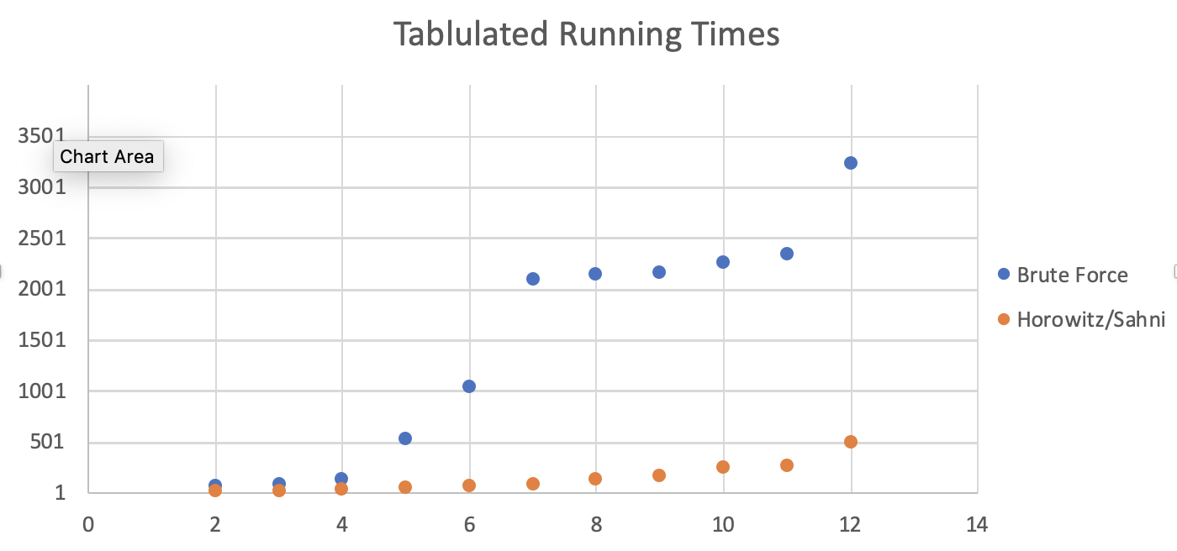

Given below is proof that my code is functional.

With the given set of S, the solution below was found by my Brute force algorithm.

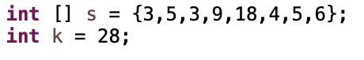



With a given set S, the solution below was found by my Horowitz/Sahni Algorithm.



